**Project Design Phase-II Technology Stack (Architecture & Stack)**

|  |  |
| --- | --- |
| Date | 13 March 2025 |
| Team ID | PNT2025MID02539 |
| Project Name | Global Food Production Trends and Analysis:  A Comprehensive Study from 1961 to 2023 Using Power BI |
| Maximum Marks | 4 Marks |

# Technology Stack (Architecture & Stack)

**Project Name:** Global Food Production Trends and Analysis (1961-2023) using Power BI

# Technical Architecture:

The project follows a structured architecture for data collection, processing, and visualization using Power BI. The architecture consists of: 1. **Data Sources**: FAO, World Bank, Kaggle datasets (CSV/Excel format).

1. Data Storage: SQL Database / Cloud Storage / Local Filesystem.
2. Data Processing: Python (Pandas, NumPy) for cleaning and transformation.
3. Data Modeling: Fact and Dimension tables in a star schema.
4. Visualization Layer: Power BI for dashboards and reports

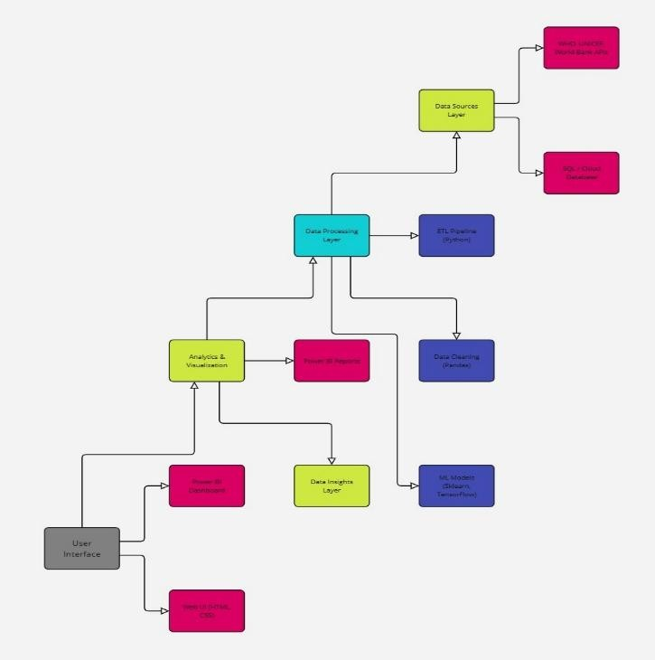

Fig. technology architecture diagram

## Table-1 : Components & Technologies:

|  |  |  |  |
| --- | --- | --- | --- |
| **S.No** | **Component** | **Description** | **Technology** |
| 1. | User Interface | Interactive Dashboard & Reports | Power BI |
| 2. | Data Storage | Storage for historical food production data | SQL / Azure / CSV / Excel |
| 3. | Data Processing | Data transformation and calculations | Python (Pandas, NumPy), DAX (Power BI) |
| 4. | Data Modeling | Fact-Dimension relationships for better analysis | Star Schema in Power BI |
| 5. | External API | Fetching live data if needed | FAO API, World Bank API |
| 6. | Infrastructure | Hosting and sharing reports Storage | Power BI Service / Local / Cloud |

**Table-2: Application Characteristics:**

|  |  |  |  |
| --- | --- | --- | --- |
| **S.No** | **Characteristics** | **Description** | **Technology** |
| 1. | Open-Source Frameworks | Data analysis and visualization tools | Python (Pandas, Matplotlib) |
| 2. | Security Implementations | Access control and data security | Power BI Role-Based Access, IAM |
| 3. | Scalable Architecture | Handling large datasets efficiently | SQL Indexing, Cloud-based storage |
| 4. | Availability | Ensuring data availability for users | Power BI Service, Azure Cloud |
| 5. | Performance | Optimized data loading and visualization | DAX Measures, Query Folding, Caching |

**References:** [**https://www.fao.org/faostat/en/**](https://www.fao.org/faostat/en/)[**https://data.worldbank.org/**](https://data.worldbank.org/)[**https://ourworldindata.org/food-agriculture**](https://ourworldindata.org/food-agriculture)

[**https://www.kaggle.com/datasets?search=agriculture**](https://www.kaggle.com/datasets?search=agriculture)